**WebTech Assignment**

**SubmitBy:-**

**Mithlendu kumar**

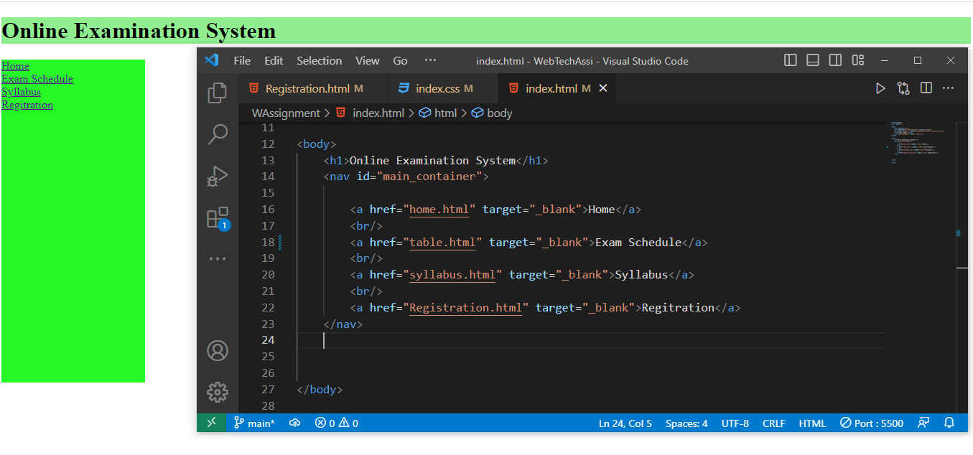

**Step1 When Click to Home**

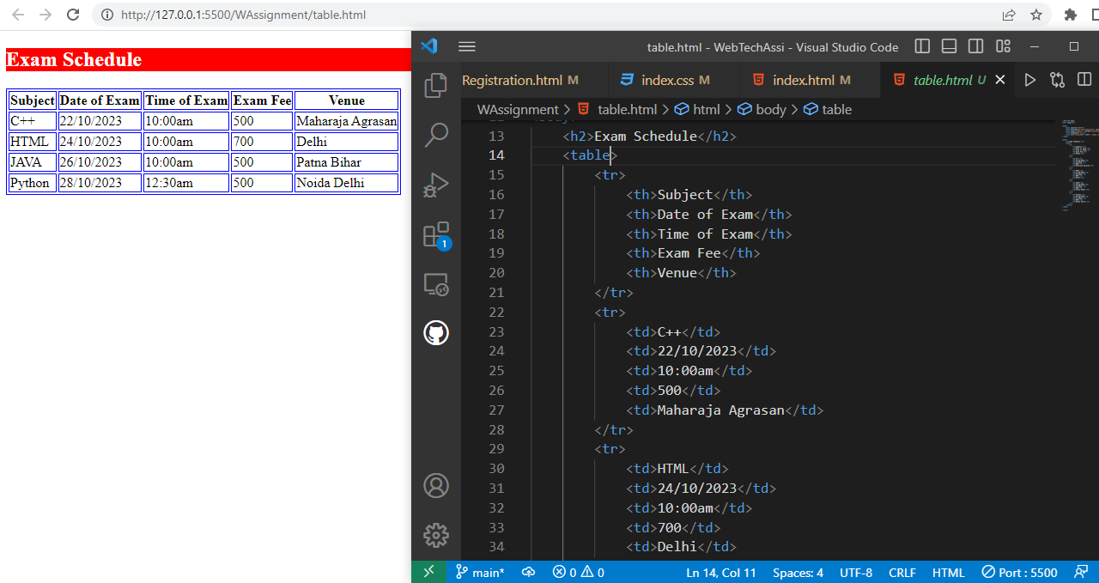

**Step2 When Click to Exam Schedule**

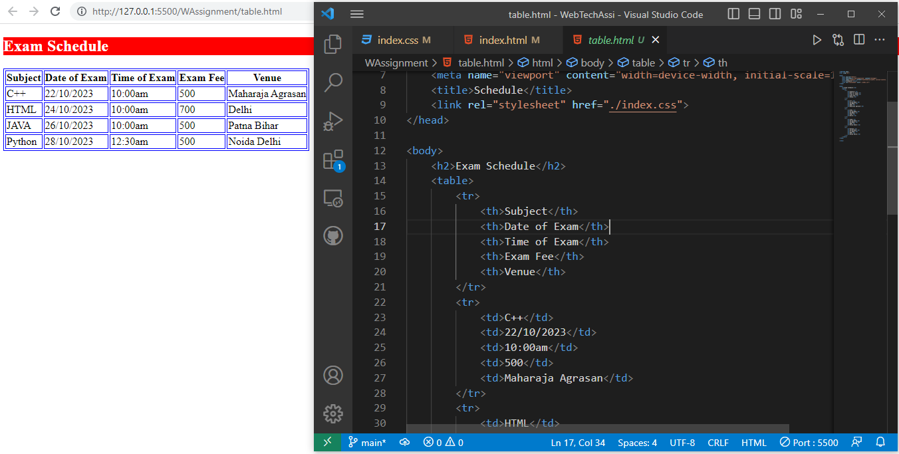

**Step3 When Click Syllabus**

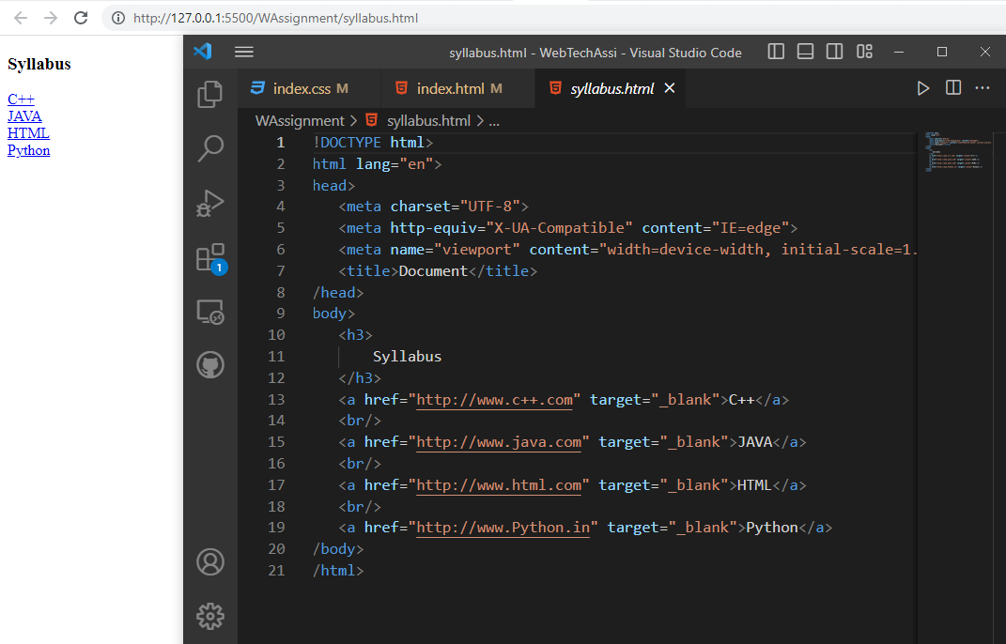

**Step4 When Click Registration Nav Bar**

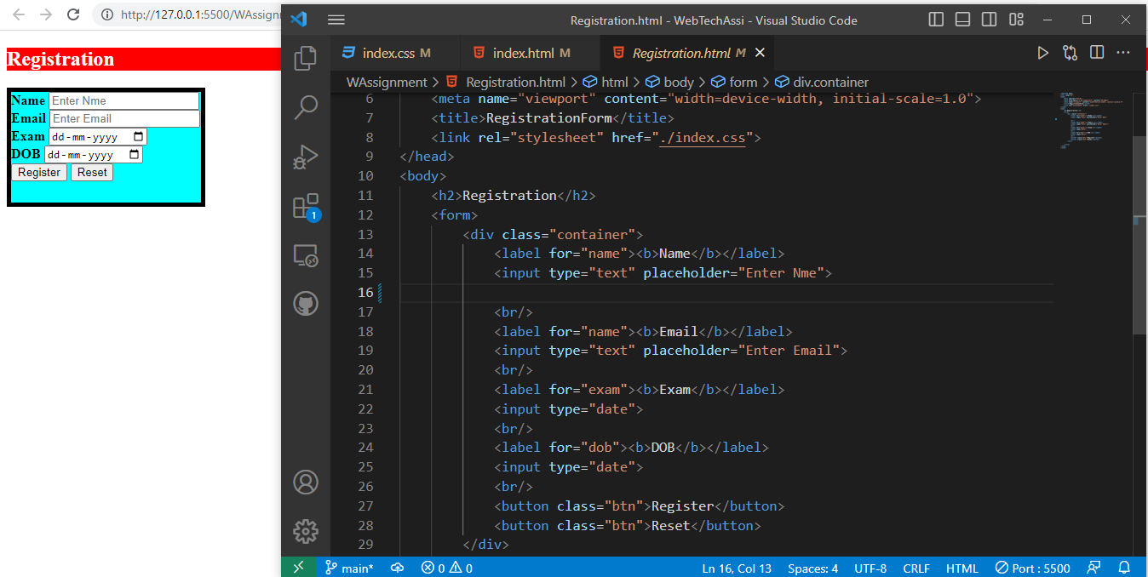

**CSS For This Project**

